Task 4: Variables, Functions, and Inheritance

Using Variables and Functions in Sass
Sass provides variables and functions to enhance the maintainability and consistency of your styles. Variables allow you to store values (such as colors, sizes, and fonts) that can be reused throughout your stylesheets, while functions enable dynamic calculations and transformations within the styles, improving flexibility.

Variables in Sass
Variables in Sass are declared using the $ symbol. They can store values like colors, dimensions, fonts, and more. You can change the value of a variable in one place, and it will update everywhere it is used.

Example: Declaring and Using Variables
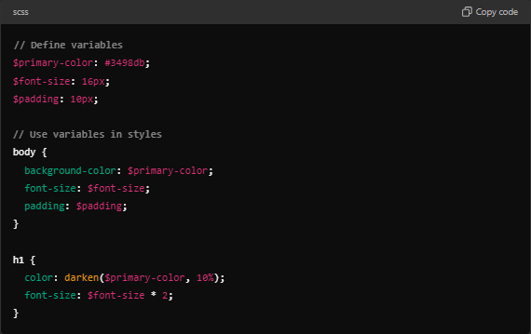
In this example:
- $primary-color is used as the background color for the body and the text color for the heading (h1).
- The darken function is applied to the $primary-color to create a darker shade.
- $font-size and $padding are used for consistency across multiple elements.

Functions in Sass
Sass includes built-in functions (e.g., for color manipulation, math, and more), but you can also define your own custom functions using the @function directive. Functions allow you to create reusable, dynamic logic that calculates values and returns a result.

Example: Declaring and Using a Custom Function
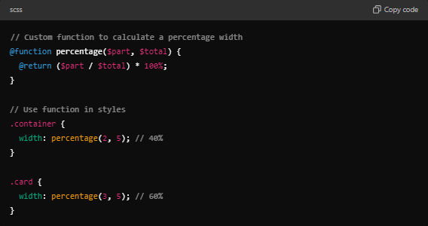
In this example:
- The percentage function takes two arguments ($part and $total) and returns the percentage as a width value.
- The .container and .card classes use the function to dynamically calculate their widths based on the ratio provided.

Inheritance in Sass
In inheritance, one selector can "inherit" the styles of another using the @extend directive. This allows shared styles to be written once and reused across multiple selectors, reducing repetition and keeping styles consistent.

Example: Inheritance in Sass
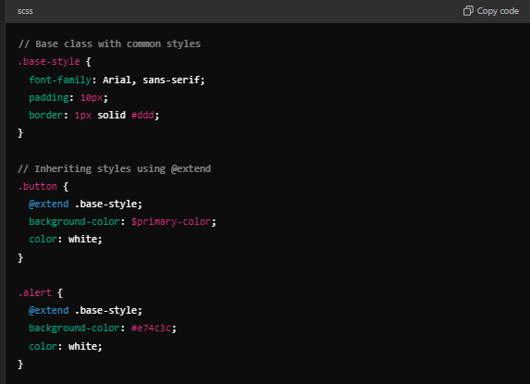
In this example:
- The .base-style class contains common styles (font family, padding, and border).
- Both .button and .alert inherit these styles using @extend, while also adding their own specific styles (background color and text color).
Resulting CSS:
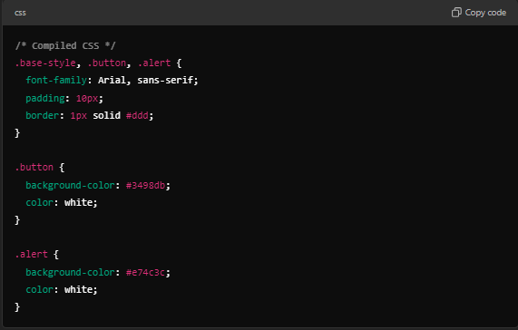

Key Concepts:
- Variables: Store reusable values like colors, sizes, and fonts, which can be applied consistently across styles.
- Functions: Allow calculations and logic within stylesheets, enabling dynamic values.
- Inheritance: Use @extend to share styles across multiple selectors, making the code more DRY (Don't Repeat Yourself) and maintainable.

Full Example Using Variables, Functions, and Inheritance
// Variables
$primary-color: #3498db;
$secondary-color: #2ecc71;
$font-size: 16px;

// Custom function to adjust font size
@function adjust-font-size($size, $factor) {
@return $size * $factor;
}

// Base class for shared styles
.base-box {
font-family: Arial, sans-serif;
padding: 20px;
border-radius: 5px;
font-size: $font-size;
}

// Component styles using inheritance, variables, and function
.button {
@extend .base-box;
background-color: $primary-color;
color: white;
font-size: adjust-font-size($font-size, 1.2);
}

.card {
@extend .base-box;
background-color: $secondary-color;
font-size: adjust-font-size($font-size, 1.1);
}

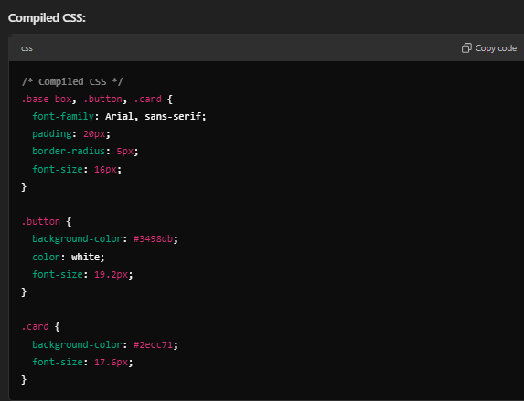
In this example:
- Variables store colors and font sizes.
- The custom function adjust-font-size dynamically calculates a new font size by multiplying the base size by a factor.
- The @extend directive ensures that .button and .card share the common base styles (.base-box), while applying unique background colors and adjusted font sizes.

Conclusion:
By using variables, functions, and inheritance, Sass helps maintain consistency and reusability in stylesheets, making it easier to manage large projects. These features reduce repetition and allow for dynamic, maintainable code.

